**Test Summary Report**

**Project Overview**

* **Project Name**: Test Case Design for Contact List App
* **Team Members**: Dina Abuqare and Mark Qarraa
* **Date**: 12/3/2025

**Test Execution Summary**

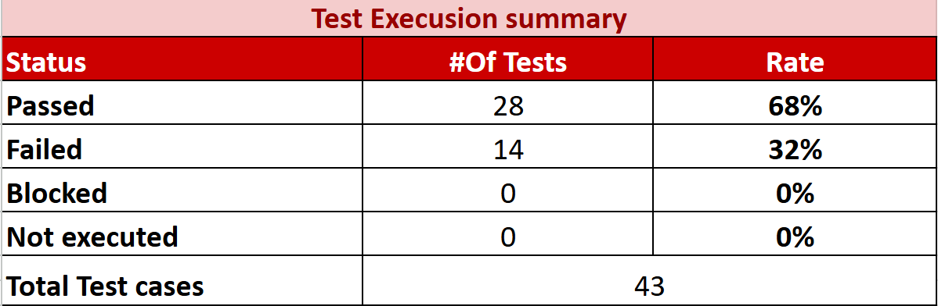

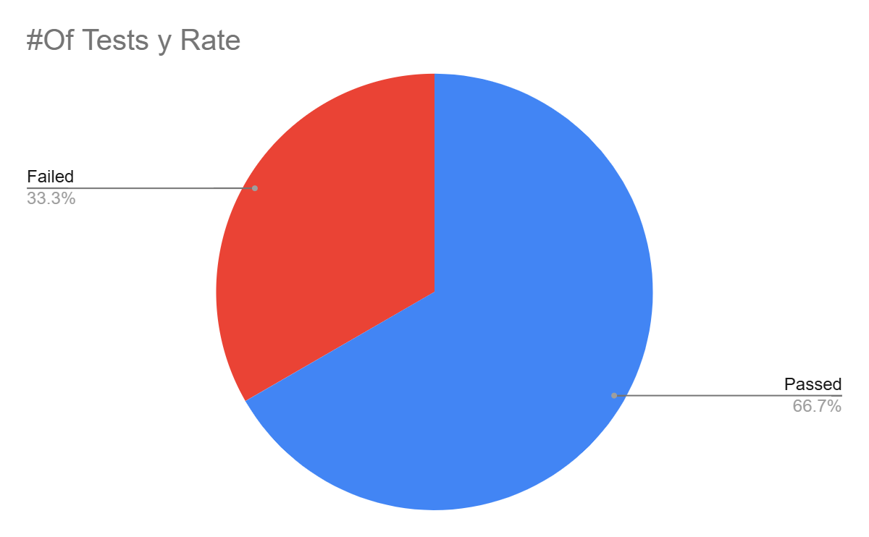

**Test Case Distribution by Type**

* **API Test Cases**: 20
* **UI Test Cases**: 23

**Test Case Status Overview**

* **Passed**: 28
* **Failed**: 14

**Test Case Priority Distribution**

* **High Priority**: 4
* **Medium Priority**: 2
* **Low Priority**: 8

**Test Case Severity Distribution**

* **High Severity**: 13
* **Medium Severity**: 1
* **Low Severity**: 0